|  |  |
| --- | --- |
| Checking/savings accounts  Project Analysis Revision 4 | Group 3  2 April 2017  Lennon Brixey  Ken Machen  Conor Maginnis  Mathew Nielsen  UMUC CMSC 495 7981 Current Trends and Projects in Computer Science (2172) Professor Hung Dao |

**Revision History**

|  |  |  |  |
| --- | --- | --- | --- |
| **REVISION #** | **DATE** | **DESCRIPTION** | **NAME** |
| **1** | **27 MAR 2017** | **Initial draft** | **Ken** |
| **2** | **28 MAR 2017** | **Review – remove print** | **Connor** |
| **3** | **29 MAR 2017** | **Diagrams** | **Matthew** |
| **4** | **29 MAR 2017** | **Only one database** | **Conor** |
| **5** | **31 MAR 2017** | **Minor text changes** | **Conor** |
| **6** |  |  |  |

**Requirements:**

|  |  |
| --- | --- |
| **Req #** | **Requirement Text** |
| **1** | This application shall have a login page |
| **2** | This application shall allow unique log-in usernames |
| **3** | This application shall not allow more than one user to have the same username |
| **4** | This application shall not save usernames in plaintext |
| **5** | This application shall force users to accept the user agreement before logging in |
| **6** | This application shall allow the user to log out and end their session |
| **7** | This application shall allow users to transfer money between accounts |
| **8** | This application shall allow users to see their transaction history |
| **9** | This application shall allow users to see their potential interest earnings |
| **10** | This application shall update interest based on a 30-day average of their account balance in accordance with their account type |
| **11** | This application shall have a menu allowing the user to navigate |
| **12** | This application shall use a database to hold usernames and passwords |
| **13** | This application shall use a database to hold the user accounts |
| **14** | This application shall allow users to have both savings and checking accounts |
| **15** | This application shall allow users to view their balance |

**PROJECT ANALYSIS**

**Analysis**

We identify the following elements of the project:

1. Outside system: the user
2. Input data: username, password, transfer amount, dates for transaction history, interest rate
3. Sources of input data: the user, database for usernames and passwords and for user accounts, navigation menu
4. Output data: account balance, interest earned, amount transferred, confirmation of transferred amount with new account balances
5. Destination of output data: computer monitor.
6. How to convert the input data into output data:
   1. user inputs username and password to login to account
   2. verify username and password against database
   3. if verified retrieve user accounts from database
      1. display selection menu with buttons for accounts, interest earned, transaction history, and transfer with amount
         1. display the user’s accounts
         2. display account balances
         3. display interest earned
         4. display transaction history
         5. display transfer amount and new account balances
   4. if not verified display login error

Context Diagram:

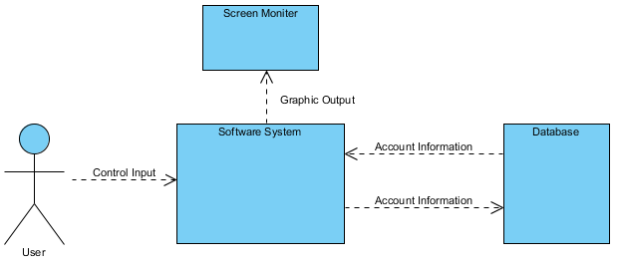

Figure Context Diagram System

Context Diagram with subsystems:

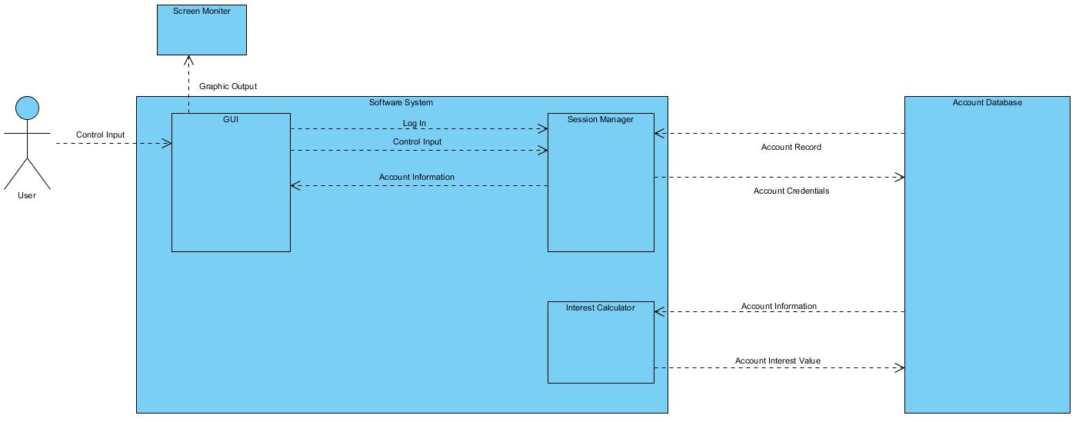

Figure Context Diagram with subsystems

Descriptions of the subsystems:

1. input subsystem: user accesses computer and account system
2. login subsystem: user inputs username and password and clicks login
3. user account subsystem: username and password database is verified
4. checking account subsystem: user account database is accessed and user information retrieved
5. savings account subsystem: user account database is accessed and user information retrieved
6. interest subsystem: interest earned is calculated with given interest rate for specified timeframe
7. account history subsystem: access account database retrieve transactions for last month
8. balance subsystem: access account database retrieve current balance